***LINUX EXERCISES – DIRECTORIES***

**\*\*Commented in class: -d** before a letter selection (for example **a\***) is done for directories (but without showing its contents **). In some of these exercises it is valid, as we have proved its functioning, but I am removing them so that my exercises are as correct as possible.

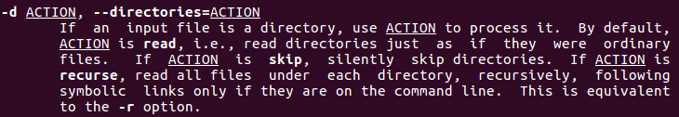

1. We need to use **<cd $HOME>**, but we should have that directory as default, so we can just type **<pwd>** and, if we are already there, keep on with our work.

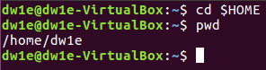

1. We have to write **<mkdir (directory_name)>**  (directory_name → systems)



1. First we have to create the “exercises” directory by typing **<mkdir exercises>**, then access it (**<cd exercises>**) and create inside it a new directory called “programming” (by typing **<mkdir programming>**).

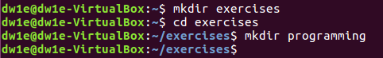

1. To remove “exercises” directory having “programming” directory in it, we will need to go to our “home” directory (typing **<cd ..>**, as we located in “exercises”) and then type **<rmdir -p exercises/programming>**, which will delete both directories.



Then we need to create these directories again but **with 1 command**, so we will type **<mkdir -p exercises/programming>** to create both with this command.



1. To list all the files in the “root” directory, the easiest way is the following: locate ourselves in the “root” (**<cd />**)) and we type **<ls>** (or even **<ls -ls>** to see them listed in block size and with some data shown) sto see all the files will be displayed.



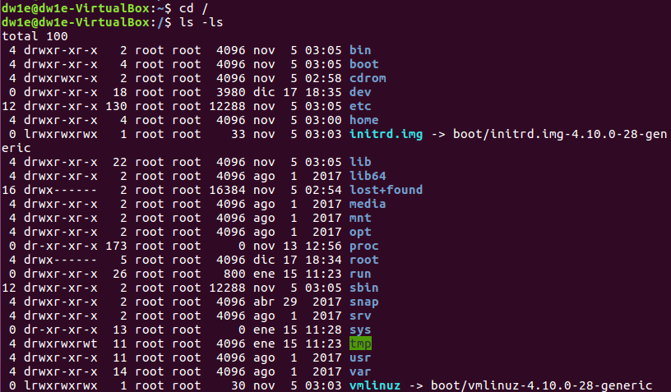

1. To list all the directories and files starting with “d”, in /usr/bin, we will have to be located in this directory by typing **<cd /usr/bin>** (we can do it inside or outside “root”). Once there, we will need to type **<ls d*>**  (“d*” to establish “d” as the first letter), and every file or directory starting with “d” will appear.

******We can also do it directly (without locating) by typing **<ls /usr/bin/d*>\*\*\*\*\*\*\***

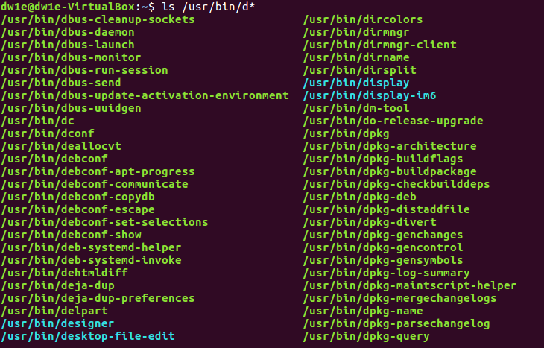

(and lots of lines below...)

1. To show all the directories and subdirectories, the command we need to use is **<ls -R>** and then add “/etc” to refer to the place from which we want to see the directories: **<ls -R /etc>**

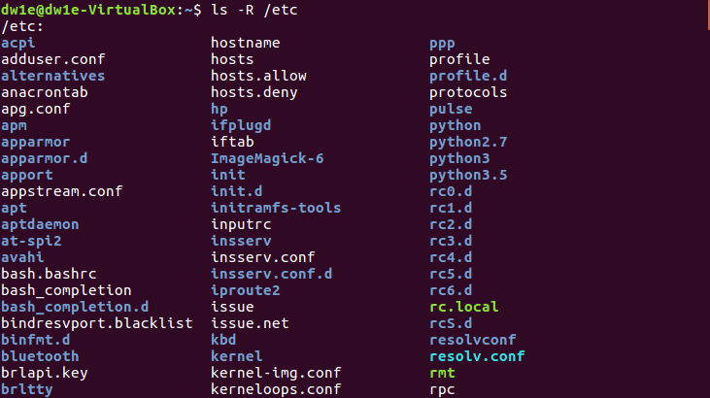

(and lots and lots of lines below…)

1. To create these files in “systems” we need to type **<cd systems>** to locate inside it and then use“touch” to create the files. We will do it with 1 command: **<touch student.txt student1.txt student2.txt list luggage last>**

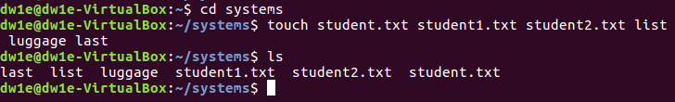

1. To list the files that start with “l” in “systems” we will have to type **<ls -d l*>**



CORRECTION: here better not to use **-d**, even though it still works. **→ <ls l*>**

1. lTo list all the files that finish with “txt” in “systems” we will have to type **<ls -d *txt>**

CORRECTION: here better not to use **-d**, even though it still works. **→ <ls l*>**

1. To create a new directory in “home” we will have to go back to it (typing **<cd ..>** (as we are in “systems”)) and create the new one, called “config” (**<mkdir config>**).



1. In order to copy all the elements from “etc” which start with “a” we need to type **<[sudo] [cp -R] [/source/letter*] [/route/reciever_directory]>**, so in this case: **<sudo cp -R /etc/a* /home/dw1e/config>** (“sudo” will be needed to have permission // “etc” is the directory we want to copy the files from // “dw1e” is the user in this case)



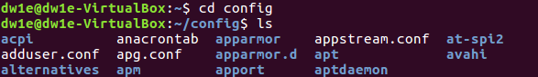

1. Finally, remove all the files finishing in “conf” we need to type **<rm -f *conf>**





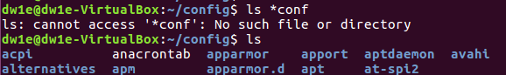

We can also use **<rm -i *conf>**, whose difference is that some warnings will appear.

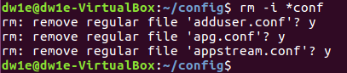

**PREVIOUS STEPS FOR THE NEXT EXERCISES**

First of all we need to create this structure (inside “exercises” directory, so “programming” should have been done in the previous exercises):

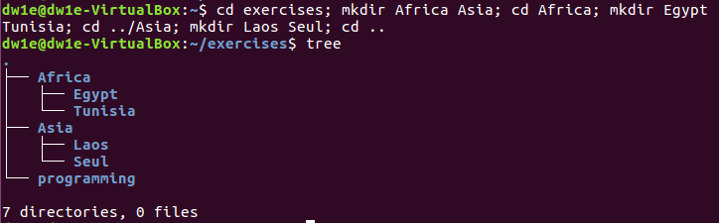

We can also create that structure typing **<mkdir -p Africa/{Egypt,Tunisia}** to create the three of them with just one command.

**The comma (,) is needed when using “{}” to create sibling directories. If we don’t use it we need to type the path with spaces between the directories, for example **<mkdir -p Africa/Egypt Africa/Tunisia>**

1. For this exercise we need to first access the directory specified (**<cd directory_name>**) and create the file using *nano* so that we can edit it at the same time (we type **<nano file_name.file_extension**).

**<cd Africa/Egypt>**

**<nano song.doc>**

**Now write some lyrics and press CTRL + X , Y and Enter to exit after saving the lyrics and the file name.

**It is right, but Sergio did everything from “exercises”, using the path for the creation of the new file (for example **<nano Africa/Egypt/song.doc>**)



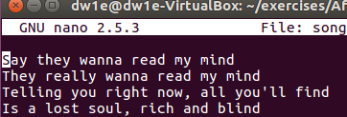

Now we change the directory to Seul (**<cd ../../Asia/Seul>**) and now we do the same with a new file (“tv.doc”), where we will write our favourite TV Show.

**<cd ../../Asia/Seul>**

**<nano tv.doc>**

**Now write our favourite TV Show and press CTRL + X , Y and Enter to exit after saving the name of the show and the file name.

**It is right, but Sergio did everything from “exercises”, using the path for the creation of the new file (for example **<nano Asia/Seul/tv.doc>**)



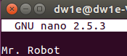

Finally, we need to do the same for a new file located in “Tunisia”, called “marks” (without extension).

**<cd ../../Africa/Tunisia>**

**<nano marks>**

**Now write our marks and press CTRL + X , Y and Enter to exit after saving the marks and the file name.

**It is right, but Sergio did everything from “exercises”, using the path for the creation of the new file (for example **<nano Africa/Tunisia/marks>**)



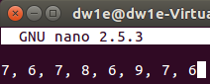

**FROM NOW ON WE WILL BE LOCATED IN “AFRICA” AND RELATIVE PATHS WILL BE NECESSARY**

1. Now we need to copy our “song.doc” from Egypt to Laos, while being in “Africa” (and the same for some of the following exercises).

**<cp -R /home/dw1e/exercises/Africa/Egypt/song.doc /home/dw1e/exercises/Asia/Laos>**



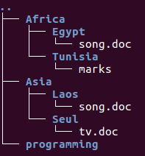

1. To copy “song.txt” as “radio.txt” in “Egypt” we need to type:

**<cp /home/dw1e/exercises/Asia/Seul/tv.doc /home/dw1e/exercises/Africa/Egypt/radio.txt>**



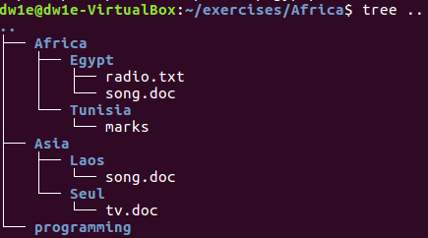

1. Now, to rename “marks” to “exam.wri” we need to type:

**<mv Tunisia/marks Tunisia/exam.wri>**



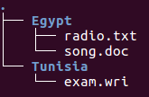

1. To copy “song.doc” inside “Tunisia” we will just type:

**<cp Egypt/song.doc Tunisia>**



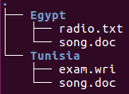

1. Now we need to print the contents of the current directory (“Africa”) with a long listing format, so we need to use **<ls -l>**

**<cd Africa/Tunisia>**

**<ls -l>**

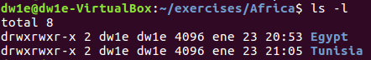

1. To rename “song.doc” to “aa.doc” we need to type:

**<mv ../Asia/Laos/song.doc ../Asia/Laos/aa.doc>**



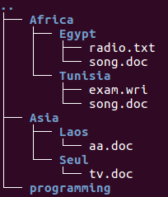

1. Now we have to create the directory “Others” in “Laos” by typing **<mkdir dir_path>**

**<mkdir ../Asia/Laos/Others>**



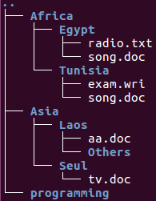

1. Again, we need to rename a file by using **<mv>**. This time will be renaming “programming” to “pro-c”

**<mv ../programming ../pro-c>**



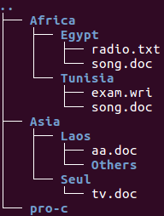

1. Now we need to create the following structure in “exercise” (using **<mkdir -p>**):

**<mkdir -p ../ONE/TWO ../ONE/THREE>**



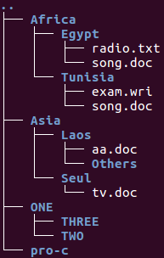

1. To copy the files from “systems” to “exercises” we need to type:

**<cp ../../systems/*txt ..>**



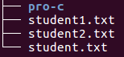

1. Now we need to move the previous files to “THREE”, so we will write:

**<mv ../*txt ../ONE/THREE>**



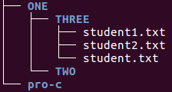

1. To delete “THREE” with all the files, directories and subdirectories in it (even though there are only files) we will need to use *-rf* in our *rm* command: **<rm -rf dir_path>**

**<rm -rf ../one/three>**





**FROM NOW ON WE WILL BE LOCATED IN “SYSTEMS” AND ABSOLUTE PATHS WILL BE NECESSARY**

1. After locating in “systems” we will copy all the files finishing with “txt” from “systems” to “Tunisia”. We will use **<cp>** with *-R* (to copy the files recursively) and *\** to filter the files:

**<cp $HOME/systems/*txt $HOME/exercises/Africa/Tunisia>**



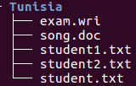

1. Now we have to copy “tv.doc” to “exercises” by typing:

**<cp $HOME/exercises/Asia/Seul/tv.doc $HOME/exercises>**



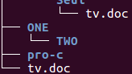

1. To rename “student1.txt” to “tuition.txt” we will use **<mv>**:

**<mv $HOME/exercises/Africa/Tunisia/student1.txt $HOME/exercises/Africa/Tunisia/tuition.txt>**



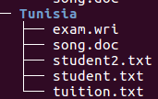

1. For the creation of a new directory (“earth”) into “systems” we will use **<mkdir>**. As we are also required to create another directory called “countries” inside “earth”, we will also use *-p* to make this process easier:

**<mkdir -p $HOME/systems/earth/countries>**



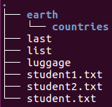

1. To rename “Africa” to “Afri” we need to type:

**<mv $HOME/exercises/Africa $HOME/exercises/Afri>**



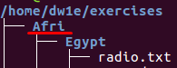

**FROM NOW ON, WE CAN BE LOCATED IN ANY DIRECTORY**

1. To move and rename “song.doc” to “Laos” as “bb.doc” we will use **<mv>** and write its new name at the end of the destination path:

**<cd $HOME/exercises>**

**<mv Afri/Egypt/song.doc Asia/Laos/bb.doc>**



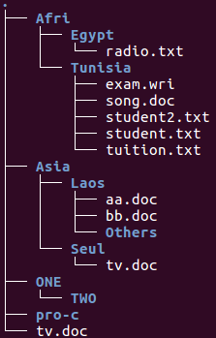

1. To copy all the files that contain the letter “u” from “systems” to “exercises” we will use **<cp>** again, and now we will add *\*u\** so that we can filter the files we want:

**<cd $HOME>**

**<cp systems/*u* exercises>**



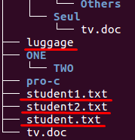

1. To print the content of “/etc” we will type **<ls>** to show it as a list and we will add *-rR* to include subdirectories and print it in reverse alphabetical order:

**<ls -rR /etc>**



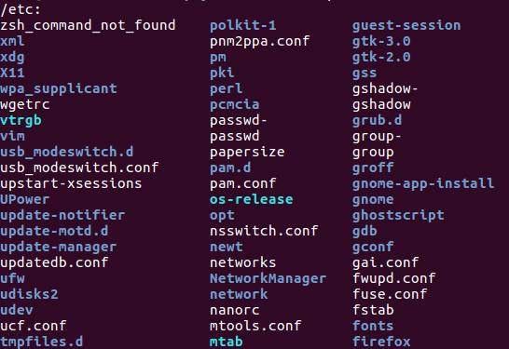

and lots of lines below…

1. To be able to know in which directory we are, we can type **<pwd> (Print Working Directory)**:

**<pwd>**



1. To copy “Afri” (with files and subdirectories) to “Asia” we will first locate into “exercises” (**<cd $HOME/exercises>**) and then copy them with **<cp -R>**:

**<cd $HOME/exercises>**

**<cp -R Afri Asia>**



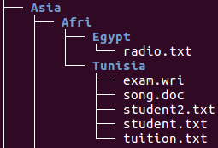

1. To move all the files and subdirectories of “Laos” to “Seul” and rename it to “Seul2” we will just use **<mv>** including the new name at the end of the destination path, so we will type:

**<mv Asia/Laos Asia/Seul/Seul2>**

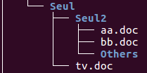

**ALFREDO PUERTA GALLEGO DW1E**